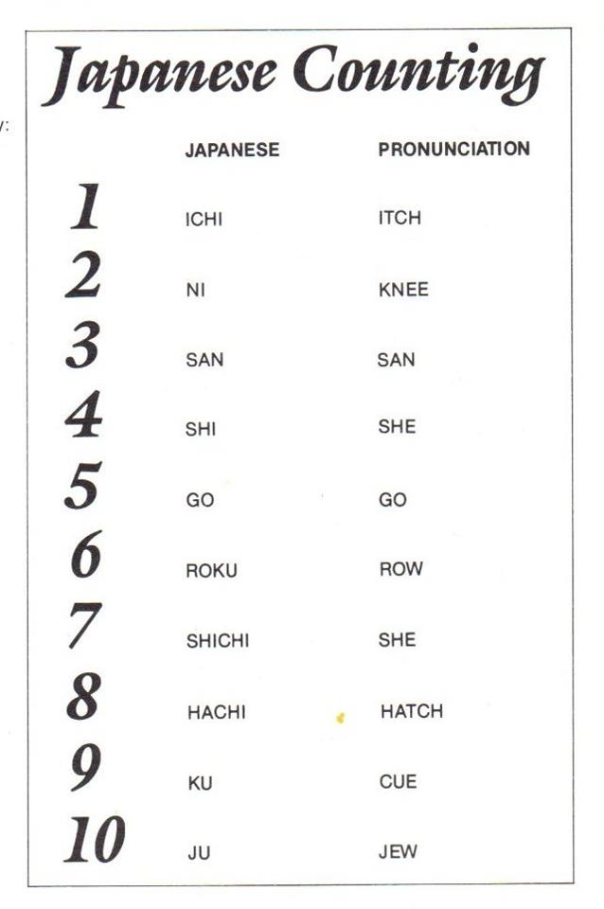

 | English | Japanese | Pronunciation
A. | One | Ichi | ee-tch
B. | Two | Ni | knee
C. | Three | San | san
D. | Four | Shi | she
E. | Five | Go | go
F. | Six | Roku | Row-ka
G. | Seven | Shichi | See-cha
H. | Eight | Hachi | Ha-tch
I. | Nine | Ku | cue
J. | Ten | Ju | jew

Stances
Basic Stances:
Japanese Definition Pronunciation
Heisoku-dachi: Block foot stance (hi-soo-koo-dah-chee)
Kokutsu dachi: Back stance (koh-koo-tsoo-dah-chee)
Kiba dachi: Horse (straddle) stance (kee-bah-dah-chee)
Shizen-tai: Natural stance (she-zen-tie)
Zenkutsu dachi: Forward stance (zen-koo-tsoo-dah-chee)
Advanced Stances:
Japanese Definition Pronunciation
Fudo dachi: Rooted stance (foo-dah-chee)
Hangetsu dachi: Half-moon stance
Neko ashi dachi: Cat stance
Sanchin dachi: Hourglass stance
Ashi mae kosa dachi: From Heian Godan

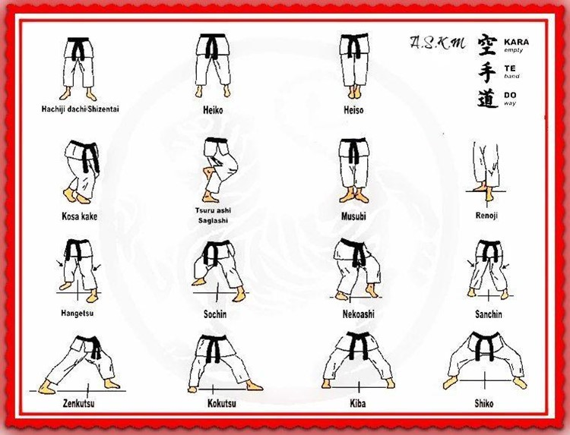
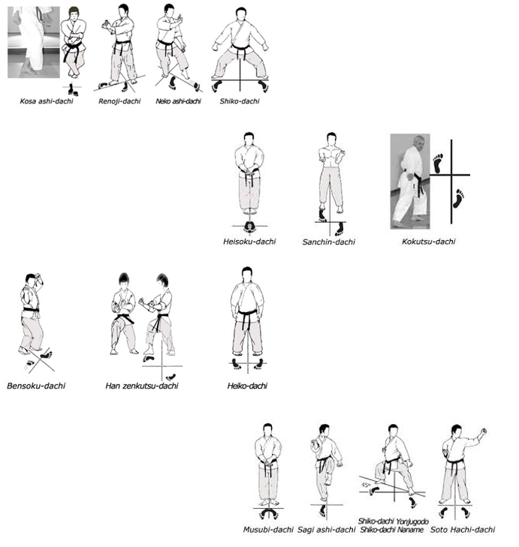

Strikes
Basic Strikes:
Japanese Definition Pronunciation
Gyaku-zuki: Reverse punch (ya-koo-soo-kee)
Haito-uchi: Ridge hand strike (high-toh-oo-chee)
Kizami-zuki: Jab (short punch) (kah-za-ma-zoo-kee)
Nukite: Spear hand (new-ka-tay)
Oi-zuki: Lunge punch (oh-ee-zoo-kee)
Shuto-uchi: Knife-hand strike (shoo-toh-oo-chee)
Teisho-uchi: Palm heel strike
Tettsui-uchi: Hammerfist (Tet-sue-ee-oo-chee)
Uraken-uchi: Backfist strike (U-ra-can-oo-chee)
Advanced Strikes:
Japanese Definition Pronunciation
Age-zuki: Rising punch (ah-gay-zoo-key)
Awase-zuki: U-punch
Haisho-ushi: Back-hand strike
Hasami-zuki: Scissors punch
Heiko-zuki: Parallel punch
Hiji-uchi: Elbow strike
Ippon-Nukite: Single finger spear hand
Ippon-ken: One-knuckle fist
Jun-zuki-kiba-dachi: Side punch moving in straddle stance
Jun-zuki-kiba-dachi-ura: Side punch moving in straddle stance (turning backwards)
Kagi-zuki: Hook punch
Mawashi-zuki: Roundhouse punch
Mika-zuki: Short upper cut
Morote-zuki: Double punch
Otoshi-empi-uchi: Downward elbow strike
Teisho-uchi: Palm heel strike
Tate-uchi: Vertical strike
Tate-shuto-uchi: Vertical sword hand
Sanbon-zuki: Three times punch
Sanbon-Morote-zuki: Three times double punch
Seiryuto-uchi: Ox-jaw strike
Shita-uchi: Short punch
Shuto-gammen-uchi: Roundhouse knife hand strike
Shuto-sakotsu-uchi: Downward knife hand strike
Ura-zuki: Close punch
Yama-zuki: Wide U-punch
Kicks
Type:
Japanese Definition Pronunciation
Keage: Snap (kay-ah-gay)
Kekomi: Thrust (kay-koh-mee)
Basic Kicks:
Japanese Definition Pronunciation
Hiza-geri: Knee kick (Hey-za-geh-ree)
Mae-geri: Front kick (my-eh-geh-ree)
Mawashi-geri: Roundhouse kick (mah-wah-shee-geh-ree)
Yoko-geri: Side kick (yoh-kee-geh-ree)
Uchi-mikazuki-geri: Inside crescent kick (mee-kah-zoo-kee-geh-ree)
Soko-mikazuki-geri: Outside crescent kick
Ushiro-geri: Back kick (oo-shee-roh-geh-ree)

Advanced Kicks:
Japanese Definition Pronunciation
Haisoku-geri: Instep kick
Nami-gaeshi-geri: Returning wave kick
Fumi komi-geri: Stomping kick
Kake-geri: Hook kick
Kansetsu-geri: Joint kick
Tobi-geri: Jump kick
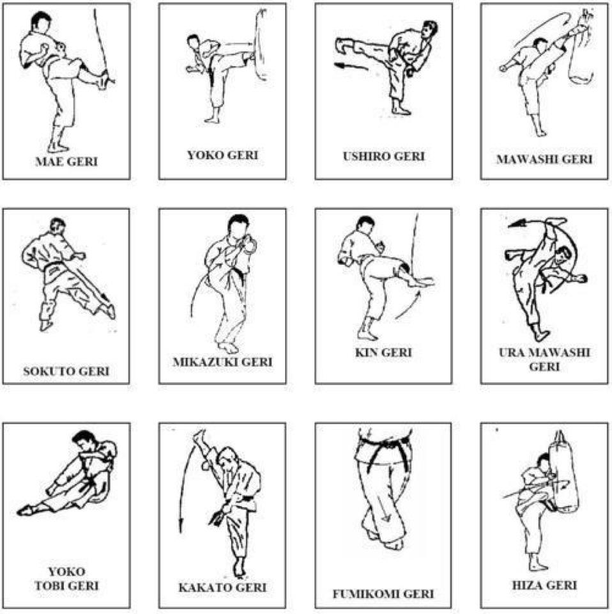

Blocks
Basic Blocks:
Japanese Definition Pronunciation
Age-uke: Rising block (ah-gay-oo-kay)
Ude uke: Forearm block (oo-day-oo-kay)
Uchi ude-uke: Inside forearm block (uchi-oo-day-oo-kay)
Gedan barai: Downward sweeping block (geh-dahn-bah-rye)
Shoto-uke: Knife-hand block (shoo-toh-oo-kay)
Advanced Blocks:
Japanese Definition Pronunciation
Gassho-uke: Double-palm-heel block
Juji-uke: X-block
Kake-uke: Hooking block
Kakiwake-uke: Reverse wedge block
Keito-uke: Chicken-head wrist block
Marote-uke: Augmented forearm block
Osae-uke: Pressing hand block
Sukui-uke: Scooping block
Tata-Shuto: Pressing knife block
Tsukami-waza: Grasping block

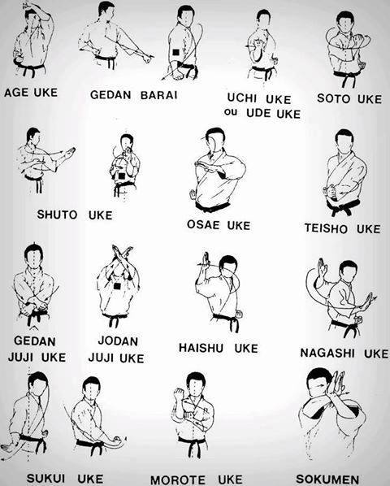
Kumite Terms:
Japanese Definition Pronunciation
Kumite: Sparring (koo-ma-tay)
Kamaete: Fighting posture
Komi hip: Prepare to begin / assume fighting posture
Hajime: Begin
Sun-dome: Arresting a technique short of contact (measurement)
Jissen: Actual sparring
Jiyu Ippon Kumite: One-attack free sparring
Sanbon kumite: Three-attack sparring
Sanbon kumite yori ashi: Three-attack sliding foot sparring
Gohon kumite: Five-attack sparring
Direction:
Japanese Definition Pronunciation
Age: Upwards (ah-gay)
Fumidashi: Stamping step
Gyaku: Opposite side (ya-ka)
Hidari: Left
Mig: i Right
Mawatte: Turn
Mawaru: Spinning
Oi: Same side
Otoshi: Downwards
Tai sabaki: Body shifting
Tobu: Jumping
Uchi: From the center line of the body outward
Ushiro: Behind
Yoko: Side (adj)
Yori-ashi: Sliding the feet
